Proposed selective licensing scheme areas in Newcastle in 2024

Background

We are proposing to introduce six new selective licensing schemes and a new additional licensing scheme for smaller Houses in Multiple Occupation (HMOs).

You can find more information about all these schemes in the ‘Proposed selective and additional licensing schemes in Newcastle in 2024 – key information’ document which can be found at: https://tinyurl.com/NCCPRSFeb2024KeyInfo

If agreed, the additional licensing scheme will be city-wide but the selective licensing schemes only apply to some areas of the city.

Below you will find maps of each area and properties included in each scheme.

Columbia Grange selective licensing area

The map below shows the boundaries for the proposed selective licensing area in Columbia Grange.

Below the map you will find details of all the properties that will be included in the scheme if it is approved.

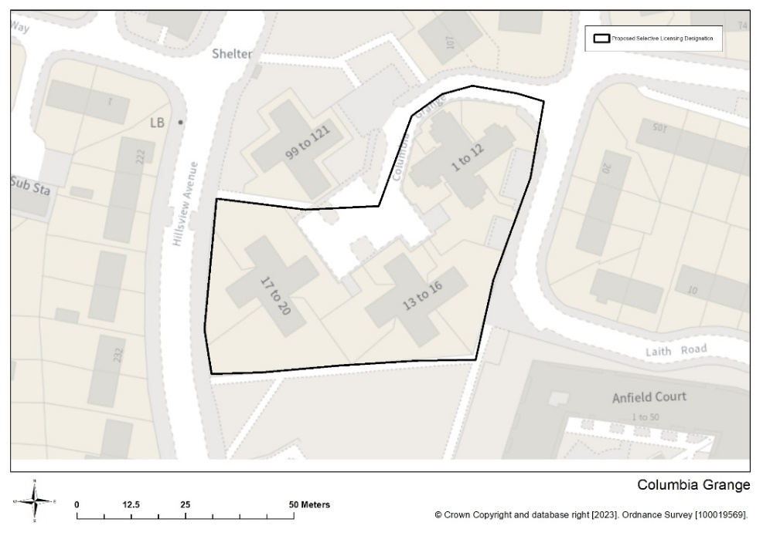

Columbia Grange property list

The proposal for a Columbia Grange selective licensing area covers the following properties.

- 1 to 20 Columbia Grange.

If you aren’t sure if your property will be included in the proposed Columbia Grange licensing area please email propertylicensing@newcastle.gov.uk

Cowgate selective licensing area

The map below shows the boundaries for the proposed selective licensing area in Cowgate.

Below the map you will find details of all the properties that will be included in the scheme if it is approved.

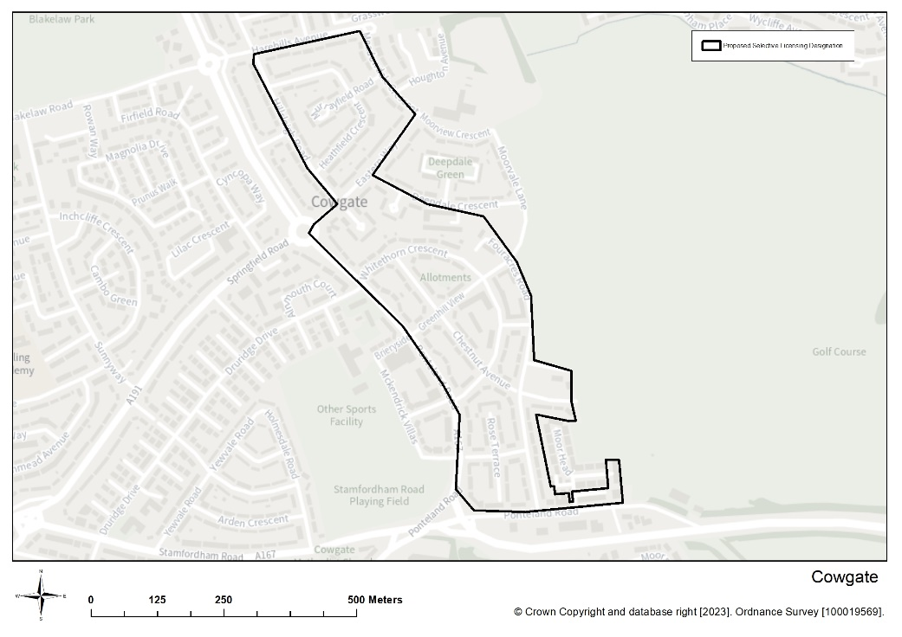

Cowgate property list

The proposal for a Cowgate selective licensing area covers the following properties.

- Aspen Terrace – all properties
- Chestnut Avenue – all properties
- 2 to 40 Deepdale Crescent – even numbers only
- 2 to 6 Eastern Way – even numbers only
- 7 to 54 Eastern Way
- Fouracres Road – all properties
- Greenhill View – all properties
- 8 to 46 Harehills Avenue – even numbers only
- Heathfield Crescent – all properties
- High Moor Court – all properties
- 2 to 58 Hillsleigh Road - even numbers only
- Link Road – all properties
- Mayfield Terrace – all properties
- 1 to 23 Meadowdale Crescent – odd numbers only
- 58 to 252 Moorside Court, Ponteland Road – even
- Rose Terrace – all properties
- The Dales – all properties
- Whinmoor Place – all properties
- Whitethorn Crescent – all properties

If you aren’t sure if your property will be included in the proposed Cowgate licensing area please email propertylicensing@newcastle.gov.uk

Denton Court selective licensing area

The map below shows the boundaries for the proposed selective licensing area in Denton Court.

Below the map you will find details of all the properties that will be included in the scheme if it is approved.

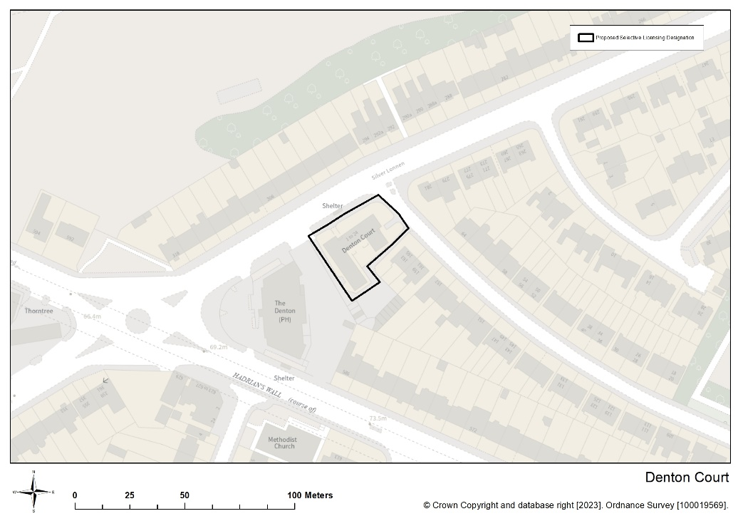

Denton Court property list

The proposal for a Denton Court selective licensing area covers the following properties.

- 1 to 24 Denton Court

If you aren’t sure if your property will be included in the proposed Denton Court licensing area please email propertylicensing@newcastle.gov.uk

HHRS selective licensing area

The map below shows the boundaries for the proposed Howdene Road, Howlett Road, Ravenswood Road and Swinley Gardens (HHRS) selective licensing area.

Below the map you will find details of all the properties that will be included in the scheme if it is approved.

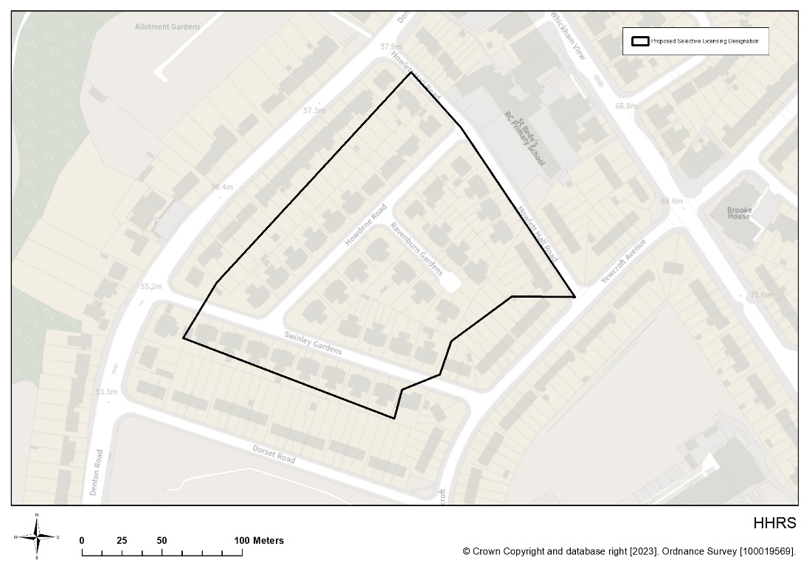

HHRS property list

The proposal for a HHRS selective licensing area covers the following properties.

- Howdene Road – all properties
- Ravensburn Gardens – all propertiess
- 7 to 42 Swinley Gardens
- 43 to 60 Swinley Gardens – odd numbers only
- 2 to 46 Howlett Hall Road – even numbers only

If you aren’t sure if your property will be included in the proposed HHRS licensing area please email propertylicensing@newcastle.gov.uk

Lemmington selective licensing area

The map below shows the boundaries for the proposed selective licensing area in Lemington.

Below the map you will find details of all the properties that will be included in the scheme if it is approved.

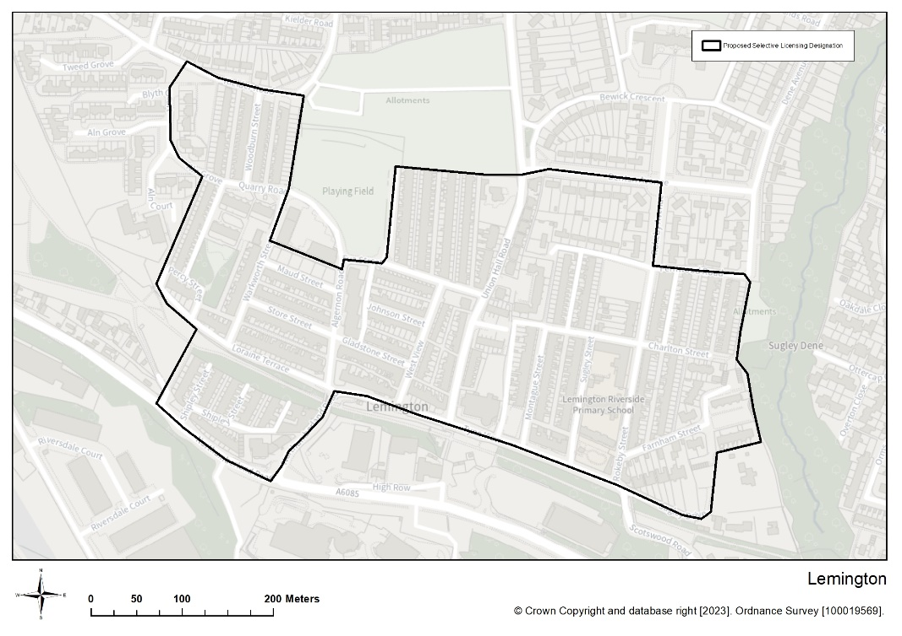

Lemington property list

The proposal for a Lemington selective licensing area covers all properties in the streets listed below.

- Addison Road
- Aldeburgh Avenue
- Algernon Road
- Allerdean Close
- Aln Court
- Aln Grove
- Alverston Close
- Apple Close
- Arundel Drive
- Avalon Drive
- Beanley Avenue
- Bells Close
- Bennett Court
- Berwick Close
- Bewick Crescent
- Birchfield Gardens
- Blanchland Avenue
- Blucher Colliery Road
- Blyth Court
- Boyd Terrace
- Brancepeth Close
- Bridgewater Close
- Broadway
- Burnham Avenue
- Bywell Avenue
- Camelford Court
- Carlton Gardens
- Celadon Close
- Centurion Road
- Charlton Street
- Claremont Avenue
- Cobalt Close
- Combe Drive
- Coquet Buildings
- Cranfield Place
- Cranford Gardens
- Crofton Way
- Dene Avenue
- Dene Gardens
- Dene Terrace
- Denton Avenue
- Denwick Avenue
- Doddington Close
- Dunnock Court
- Eldon Place
- Eldon Road
- Ellington Close
- Elmwood
- Eva Street
- Falstone Avenue
- Farnham Close
- Farnham Street
- Fernwood Road
- Flexbury Gardens
- Front Street
- Gladstone Street
- Grasmoor Place
- Hamsterley Crescent
- Hartside
- Heston Court
- Henlow Road
- High Row
- Hillside Avenue
- Honister Close
- Honister Place
- Horncliffe Walk
- Hulne Terrace
- Ingoe Street
- Jade Close
- Johnson Street
- Kielder Road
- Kirkston Avenue
- Lamedon Mill Court
- Layburn Gardens
- Leabank
- Lemington Court
- Lepidina Close
- Lesbury Street
- Letch Way
- Linnel Drive
- Lintzford Gardens
- Lockerbie Gardens
- Loraine Terrace
- Malton Close
- Malvern Court
- Maple Close
- Mapperley Drive
- Marsham Close
- Matfen Close
- Maud Street
- Meadow Road
- Medburn Road
- Melrose Close
- Mercia Way
- Montague Street
- Moorcroft Close
- Moorcroft Road
- Moorway Drive
- Morston Drive
- Moss Close
- Neptune Road
- Neville Road
- Newarth Close
- Newbury Close
- Newdene Walk
- Newton Close
- Nile Close
- Norfolk Way
- North Lea
- Northumberland Road
- Norton Way
- Norwood Road
- Oakdale Close
- Oakenshaw
- Old School Drive
- Orchard Rise
- Orchard Terrace
- Orchard – Leigh
- Ordley Close
- Orminscraig
- Ormiston
- Ormskirk Close
- Ottercap Close
- Ottershaw
- Ottringham Close
- Overton Close
- Pangbourne Close
- Park Rise
- Patina Close
- Percy Street
- Redesdale Close
- Resida Close
- Rokeby Avenue
- Rokeby Street
- Rokeby Villas
- Romsey Grove
- Rydal Road
- Sage Close
- Saint Georges Place
- Saint Georges Terrace
- Saint Vincents Close
- Shamrock Close
- Shelford Gardens
- Shipley Street
- Simpson Terrace
- Southfork
- Southway
- Spencer Terrace
- Stephenson Terrace
- Store Street
- Styford Gardens
- Sugley Drive
- Sugley Street
- Sugley Villas
- Tedham Road
- Tewkesbury Road
- The Crossway
- The Orchard
- The Ramparts
- Tweed Grove
- Tyne View
- Tynevale Terrace
- Union Hall Road
- Valley Court
- Valley View
- Wallington Drive
- Warenmill Close
- Warkworth Street
- Waverley Crescent
- Wedgewood Cottages
- Wellington Street
- West Copperas
- West Denton Close
- West Denton Road
- West Road
- West Spencer Terrace
- West View
- Wingate Close
- Wishaw Rise
- Woodburn Street
- Woodvale Gardens
- Wooler Green
- Woolerton Drive

If you aren’t sure if your property will be included in the proposed Lemington licensing area please email propertylicensing@newcastle.gov.uk

West End Terraces selective licensing area

The map below shows the boundaries for the proposed West End Terraces selective licensing area.

Below the map you will find details of all the properties that will be included in the scheme if it is approved.

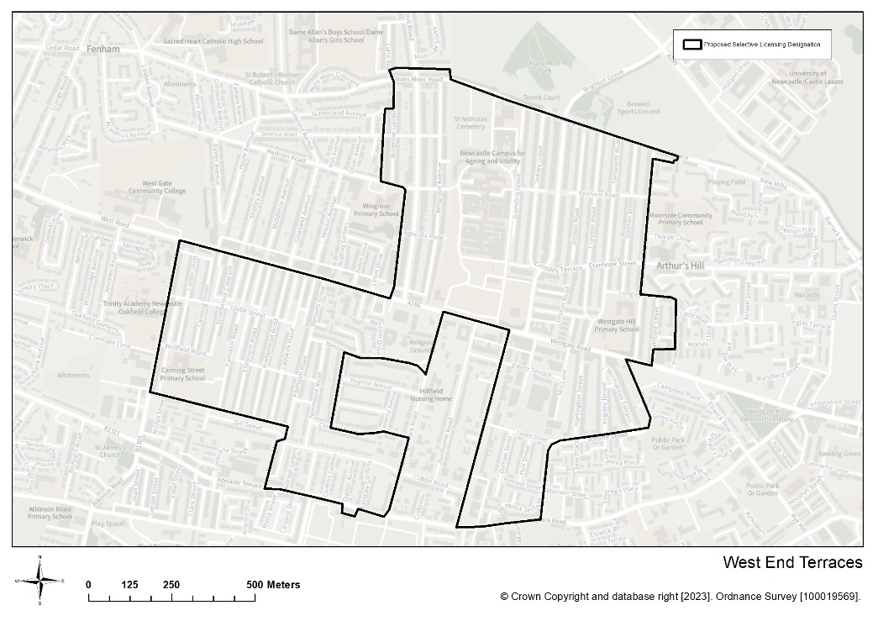

West End Terraces property list

The proposal for a selective licensing area in West End Terraces covers the following properties.

- Agricola Road – all properties
- Axbridge Gardens – all properties
- Barnesbury Road – all properties
- 2 to 100 and 314 Beaconsfield Street – even numbers only
- 103 to 319 Beaconsfield Street – odd numbers only
- Beech Street – all properties
- Belsay Place – all properties
- Bentinck Road – all properties
- Benwell Grove – all properties
- Bishops Avenue – all properties
- Brancepeth Avenue – all properties
- Brighton Grove – all properties
- Callerton Place – all properties
- Canning Street – all properties
- Chelsea Grove – all properties
- 51 to 53 Clifton Road – odd numbers only
- 54 to 116 Clifton Road – even numbers only
- Cliftonville Avenue – all properties
- Clovelly Avenue – all properties
- Colston Street – all properties
- 42 to 324 Condercum Road – even numbers only
- Cookson Street – all properties
- Coventry Gardens – all properties
- Crossley Terrace – all properties
- Croydon Road – all properties
- 2 Curtis Road
- Dilston Road – all properties
- Dipton Avenue – all properties
- Durham Street – all properties
- Eastgate Gardens – all properties
- Ellesmere Gardens – all properties
- Elliott Terrace – all properties
- Elswick Road – all properties
- Fairholm Road – all properties
- Farndale Road – all properties
- Fenham Road – all properties
- Gainsborough Grove – all properties
- Glebe Street – all properties
- 3 to 19 Grainger Park Road
- 37 to 71 Grainger Park Road
- Graingerville North – all properties
- 1 to 9 Hadrian Road
- Hamstead Road – all properties
- Hartington Street – all properties
- Hull Street – all properties
- Keldane Gardens – all properties
- Kingsley Terrace – all properties
- Ladykirk Road – all properties
- Longley Street – all properties
- Lynnwood Terrace – all properties
- 262 and 264 Mill Lane
- Normanton Terrace – all properties
- Normount Avenue – all properties
- Normount Gardens – all properties
- Normount Road – all properties
- Northcote Street – all properties
- 2 to 46 Nuns Moor Road
- 47 to 55 Nuns Moor Road – odd numbers only
- Philip Street – all properties
- Portland Street – all properties
- 7 to 43 Prospect Place
- Sceptre Street – all properties
- 1 to 22 Severus Road
- Sidney Grove – all properties
- 257 to 294 Stanhope Street
- Stanton Street – all properties
- Strathmore Crescent – all properties
- Studley Terrace – all properties
- Tamworth Road – all properties
- Tiverton Avenue – all properties
- Tweed Street – all properties
- 7 to 20 Walter Terrace
- Wellesley Terrace – all properties
- Wellfield Road – all properties
- 1 to 75 West Road – odd numbers only
- 2 to 40 Western Avenue
- Western Drive – all properties
- 368 to 585 South View, Westgate Road
- Wingrove Avenue – all properties
- 7 to 139 Wingrove Gardens – odd numbers only
- 38 to 138 Wingrove Gardens – even numbers only
- 1 to 179 Wingrove Road

If you aren’t sure if your property will be included in the proposed West End Terraces licensing area please email propertylicensing@newcastle.gov.uk

